Measuring similarly: the cosine

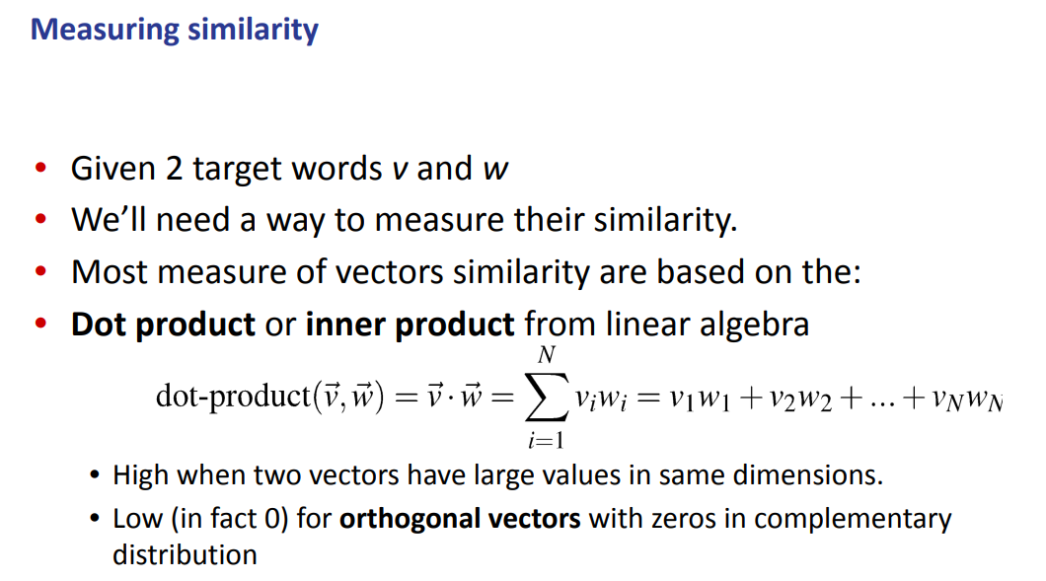
How to build different type of matrix as representation of the words in a vocabulary

Cosine similarity across vectors: one type is the dot product.
Using the dot product (to measure similarly across vectors) but it has some problems. It is simply the sum of the multiplication of each value in each dimension.
- Longer vector will have higher values

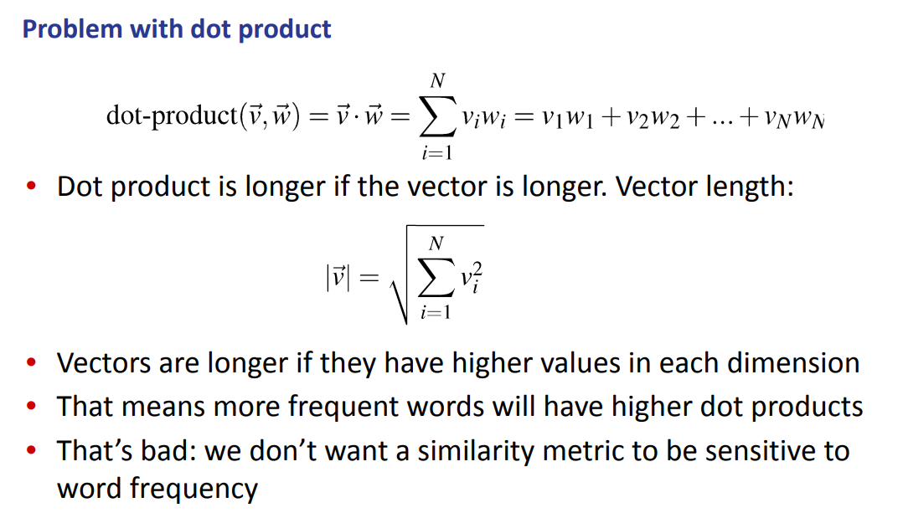

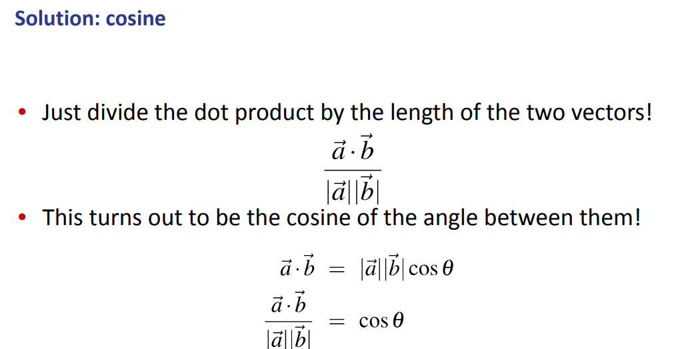
To overcome the problems of the dot product we use cosine similarity: it uses the dot product as normalized based of the length of the two vectors ⟹ gives us a solution to the problem we seen before

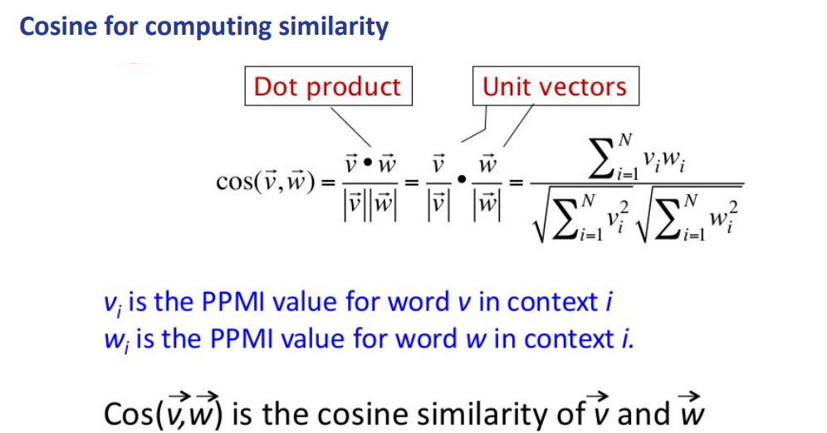

To compute the cosine similarity it is just a normalization of the multiplication of the two vectors.

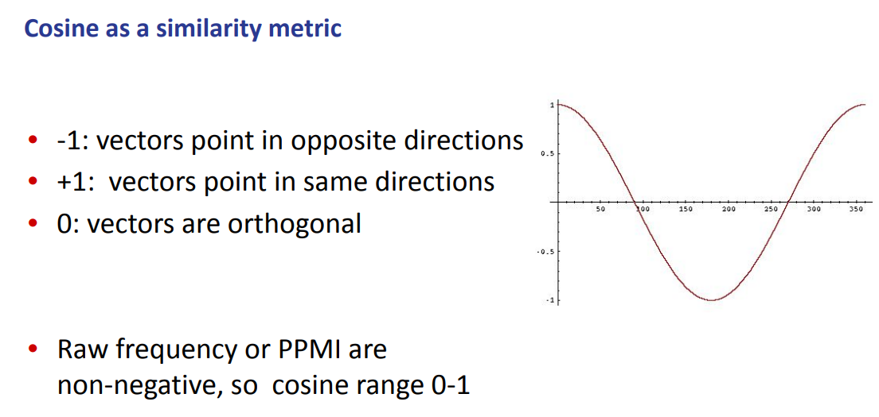
The cosine similarity metric have a bound of [-1,1] but if we do have some non negative values than the cosine ranges between [0,1]

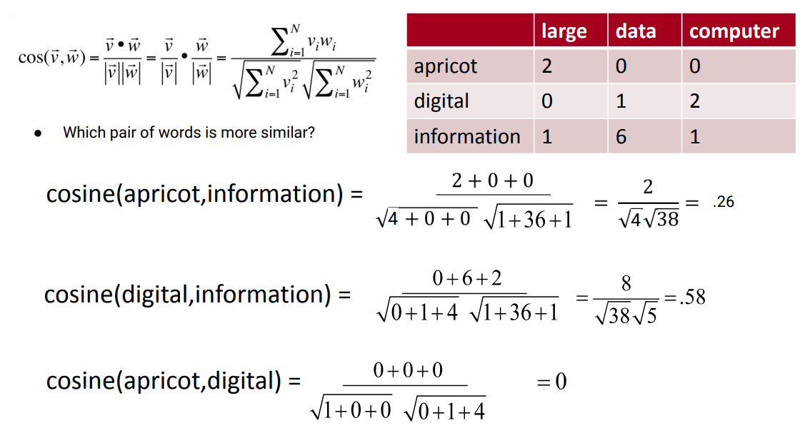
cosine(apricot, information) = sum of (apricot element * information element) / (√squared apricot line) (√squared information line)

$cosine(apricot, information) =\frac{sum of (apricot element * respective information element in the same column)}{\sqrt{squared apricot line} ⋅ \sqrt{squared information line}}$

PYTHON FILE
Python file

LANGUAGE MODEL

How the neural model works.

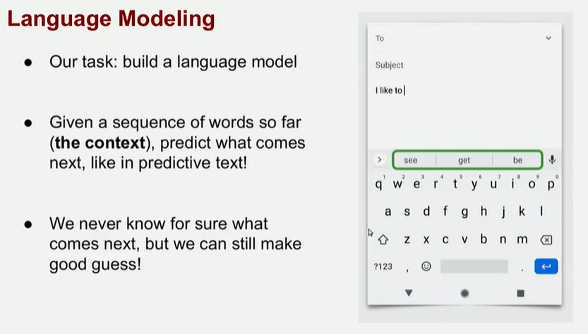
Language modeling is a task that given a sequence of words (aka context) we need to predict what comes next. The model tries to guess what is the most likely word to come next.

We never know for sure what come next (we can not predict the future) but we can make some good guess, we want a system with the best guess possible

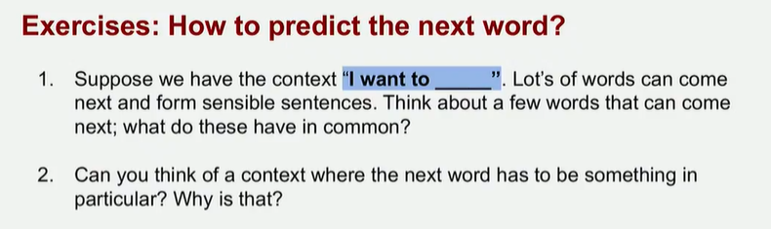
I want to ___
We can restrict to just verbs, we already have an hint of what it might come next

we want to build something that produces good guessing, some verbs are more used than other, even if they are grammatical correct are less likely

Situation in which there is only one correct word.
the capital of Nebraska is ___
The difference is that there is only one correct answer, still grammatically correct. Only one is correct. ALL the other words are wrong.

Out of all the words in our vocabulary

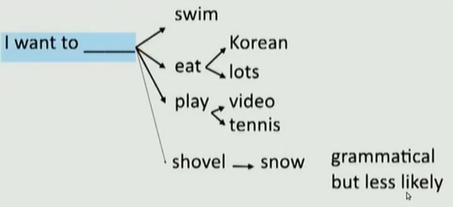
I want to shovel is actually unlucky. Is a rare event, we want to build a system that produces the good guessing, some verbs are more likely than others, but all are still grammatical correct

Why language modeling
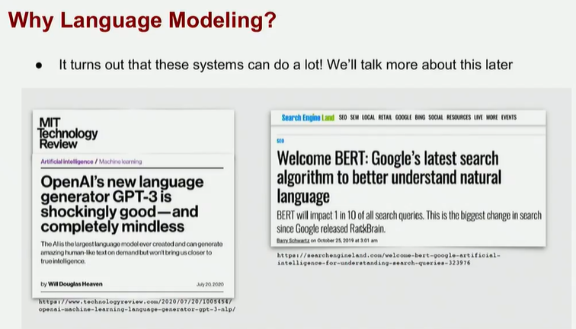
The system can do a lot

If a model is actually able to predict what comes next in a good way it needs to have learned internally the syntax.
If a model is good enough to do the task it encodes different properties of the language (it understand the syntax of the language)

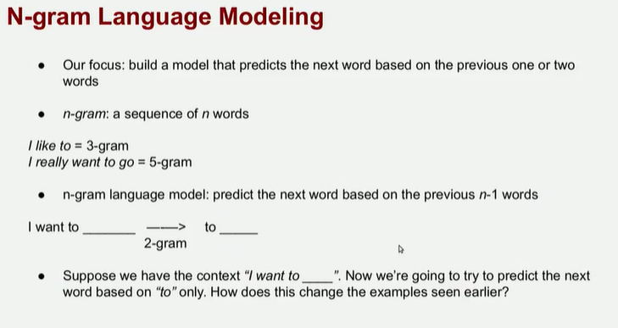
Build our first language model, all the models are based on the data and on the statistics of that data.

n-gram: sequence of n-words (bi-gram, tri-gram,...). It means how long it our sequence that we are interested on

The focus is to build a model that predict what come next based on the previous 1 or 2 words
(trigram ⟹ predict what come next based on the two words before)

2-gram: based on 1 word. It is based to n-1 words before, we use less context

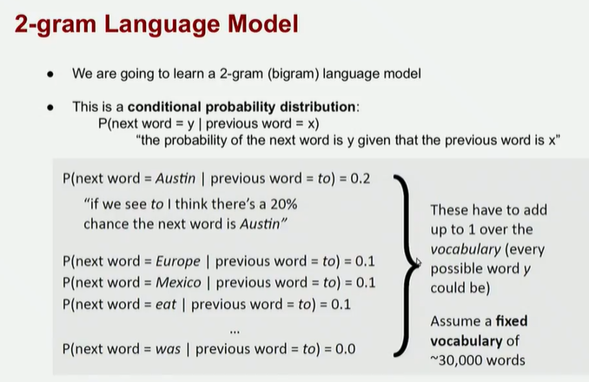
how to encode a bigram language model.

We need to predict the next word based on the previous word.
P (next word = Austin | previous word = to ) = 0.2 ⟹ “if we see to I think there's a 20% change the next word is Austin”

We can actually compute the probability of each word

It is a probability distribution, all the possibilities should add to 1. (assume we a fixed vocabulary)

First we need to decide how many words are in a vocabulary, then we can compute the probability.

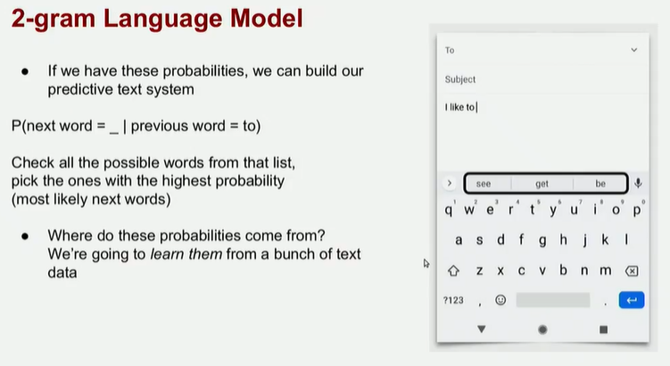
If we have all the probability we can build out predictive text system

Check all the possible words from that list, pick the three (example) with the higher probability (aka more likely)

Where does the probability come from? we learn the one from the data

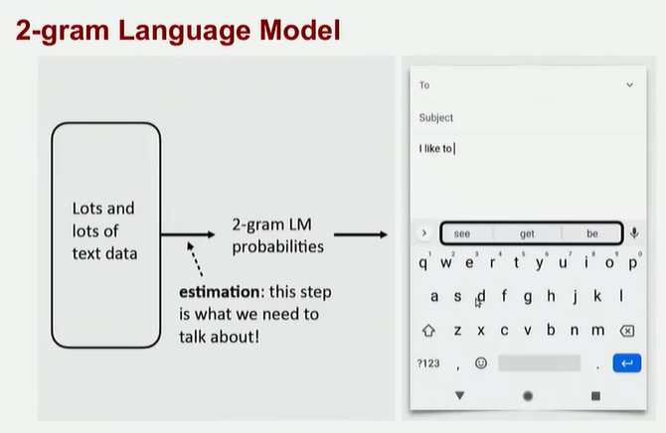
we have lots of text data, learn all the probability, then we can apply to our system

The most important step is estimation: how the probability are computed.

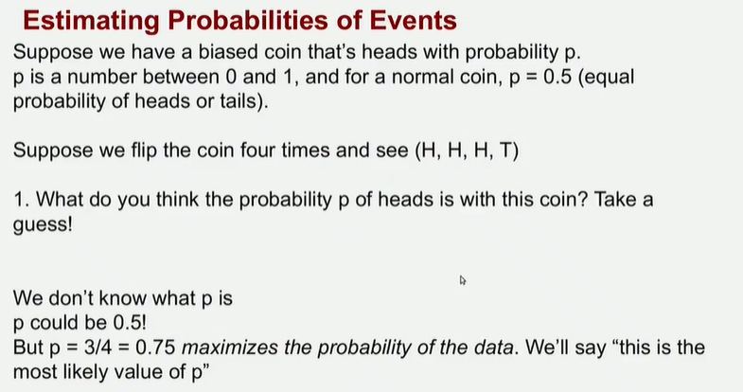
0.75 maximizes the probability of the data. Most likely value of p.

We want to maximize the probability of the next word given the context that we have

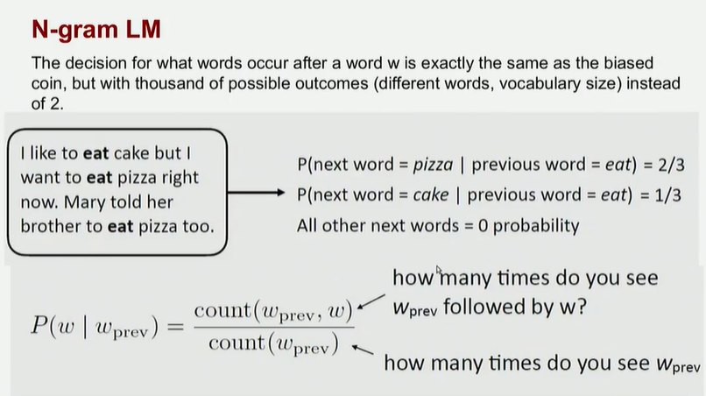
Depending on the vocabulary size, there are a lot of possible outcomes.

eat appear 3 times, we can estimate the probability of pizza

We count the probability of a word given the previous one. And we count how many time the words appear together in exactly that order and then we divide by the number of times the context words appear in the text

----------

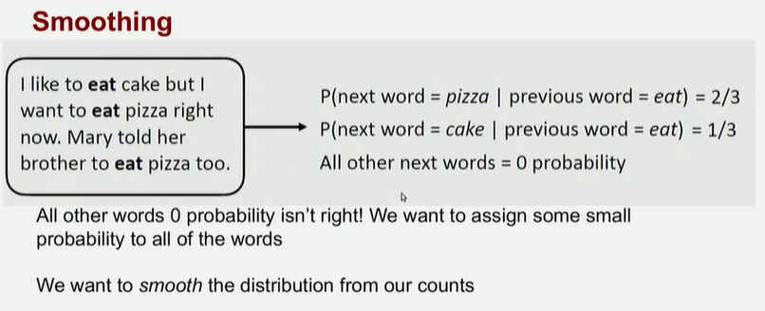

Problem: all other words have 0 probability is not right, we want to assign some small probability, we want to smooth the distribution
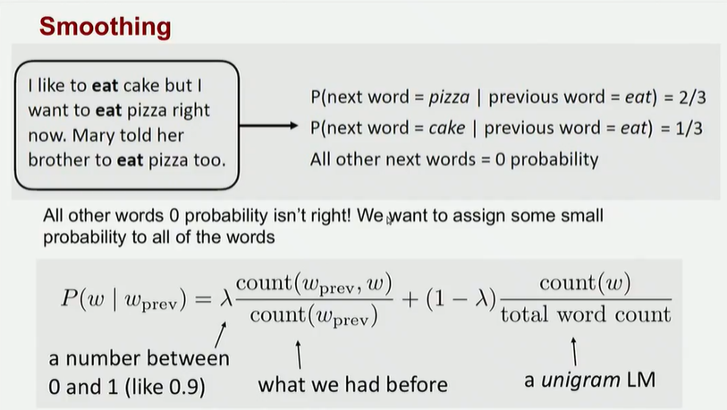

we can use a unigram and smooth the two probability
the probability of having the words together + the probability of having the word by itself

weight how much the probability with a number between 0 and 1, weights how much each probability counts.

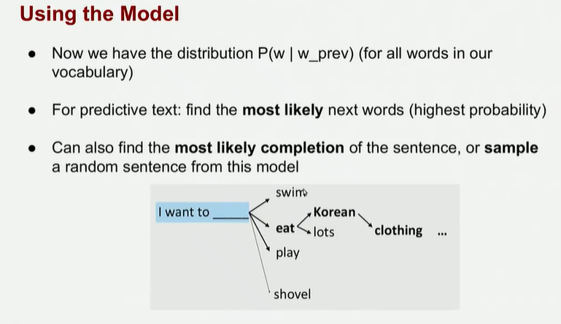
Once we have build all the table of probability we can use the distribution to build our model to find the most likely next words (that is the one with the highest probability)

and find the most likely completion of a sentence

We can start from a small context and let the model generate word after word

Language Models (recap)
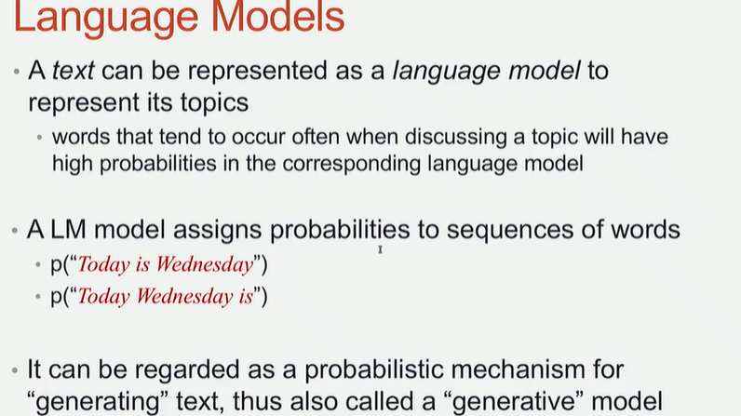
A language model is a model that assigns probability to sequences of words. Given a sentence we can ask the model what is the probability for the sentence to occur.

asking the model which one is the most likely, if the model is good the probability of the first is more high

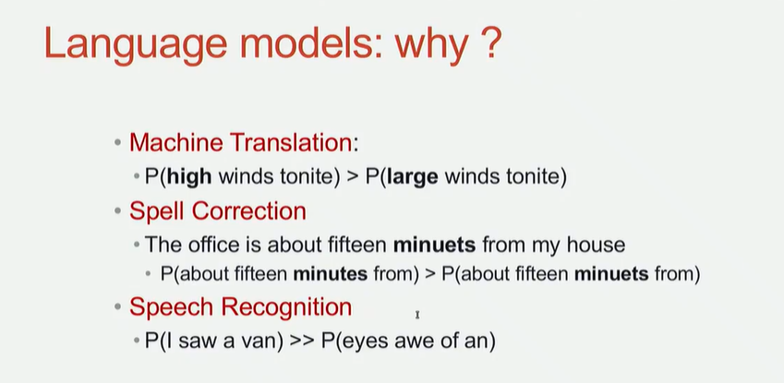
if we want to see which sentences are grammatically correct.

model to correct misspelling, we can compute the probability of having that word.

language models can be used for many applications.

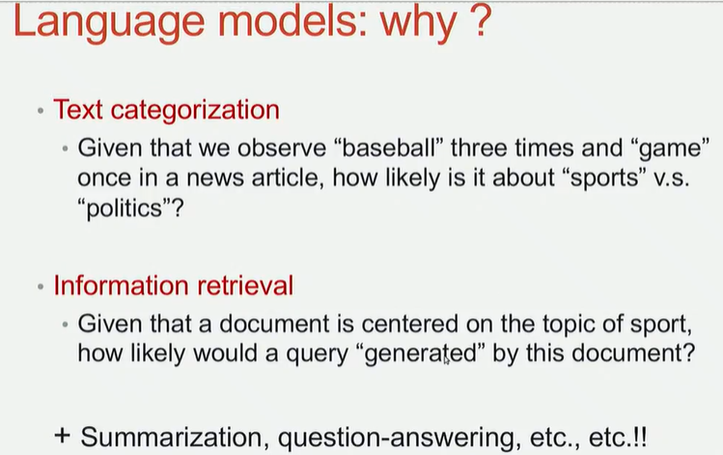
can be used for text categorization. Categorize a newspaper article if it is about politics or sport. If we observe the word baseball more time than the news will be more probability about sport.

can use only information retrieval, use google search for writing query.

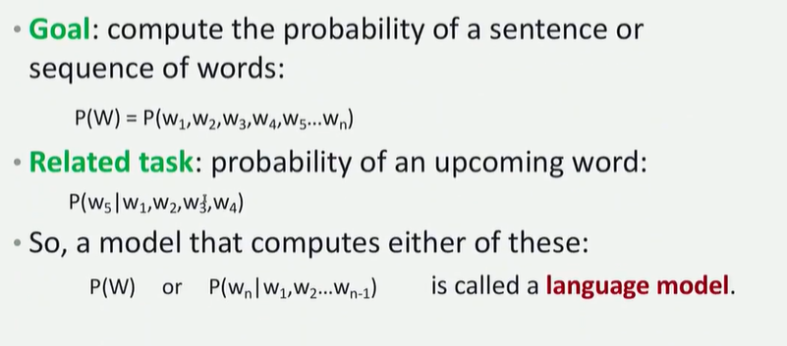
language model:
GOAL: compute the probability of a sentence

W can be a sequence of words

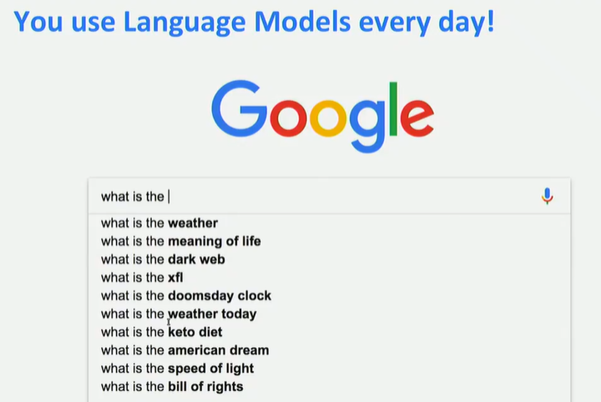
you use language model everyday, the suggestion you have are based on language model

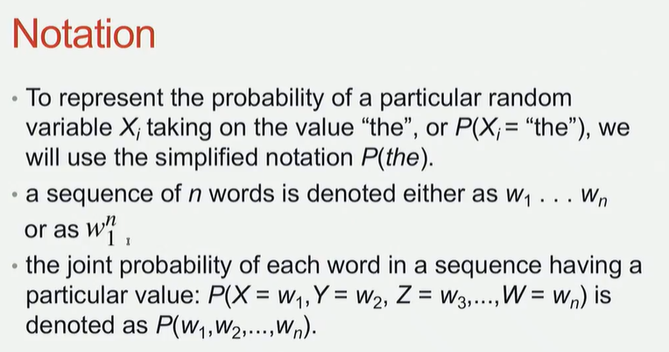
notation.

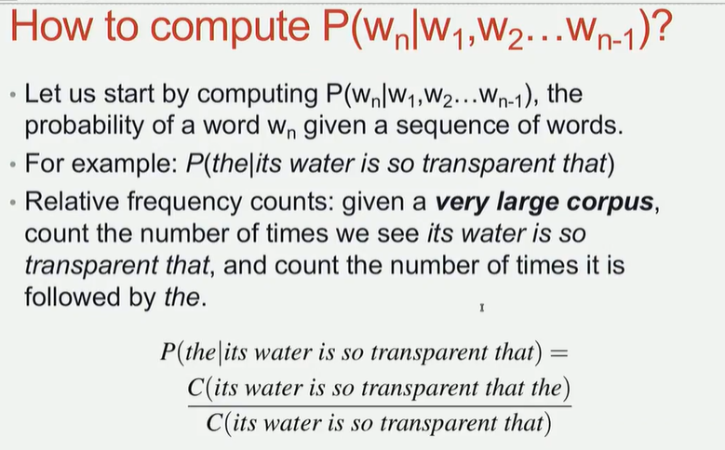
if I increase the n of the ngram I can build a better system. But is not true, is not always the case. There are two many complex sentences, at most 5 gram (no more), there are a lot of possible combination of words, use 5 gram or 3 gram

Too many possible sentences
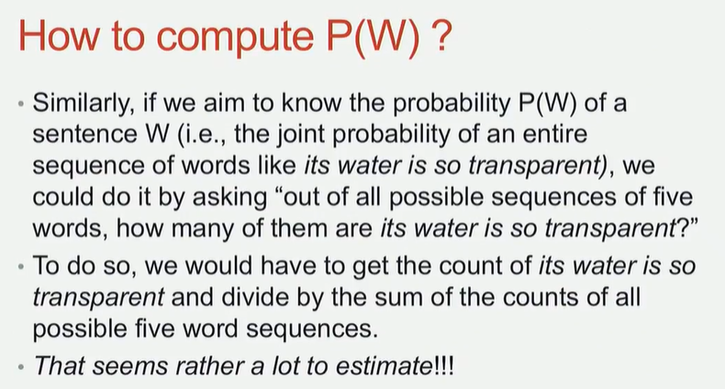
To compute the probability of the entire sentence, need to ideally calculate the probability of all combinations of n words, it is too complex. We need to simply

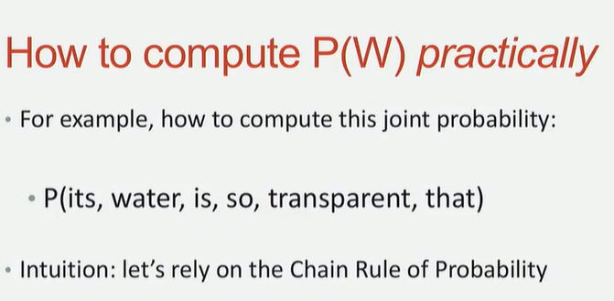
we rely on the chain rule of probability to simplificare the probability of a sentence

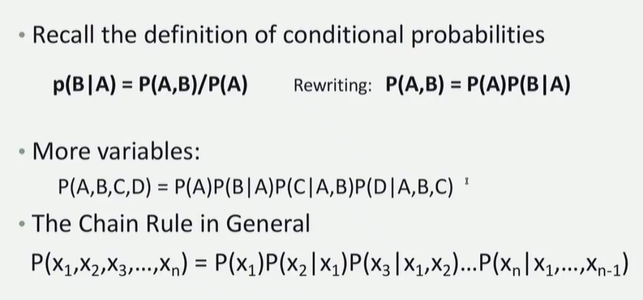
chain rule

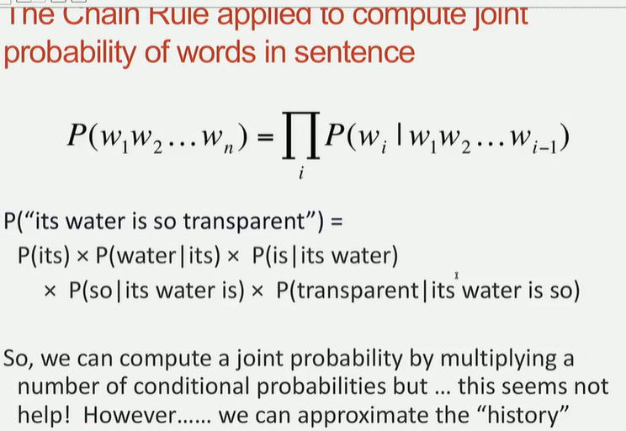
we want to approximate even more

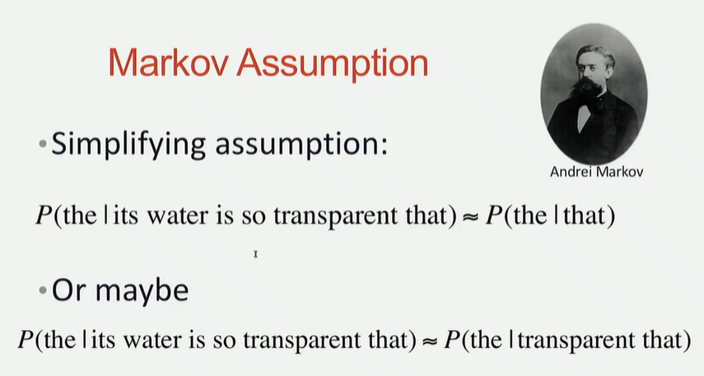
markov assumption
we rely our constraint. in this way we can compute the probability and use it as the approximation

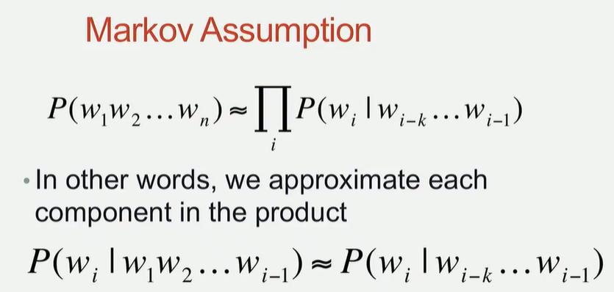
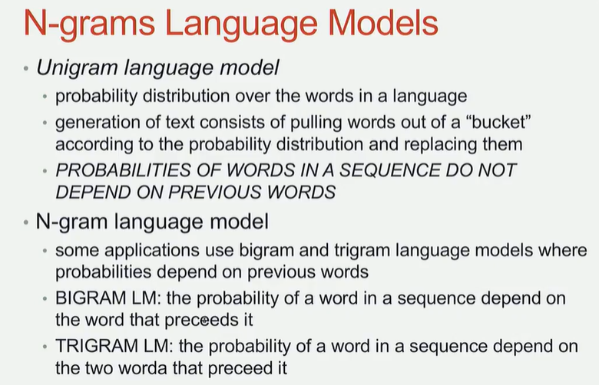
the unigram language model rely just on the probability distribution over the word

how many times a word appear, the unigram do not depends on the previous context

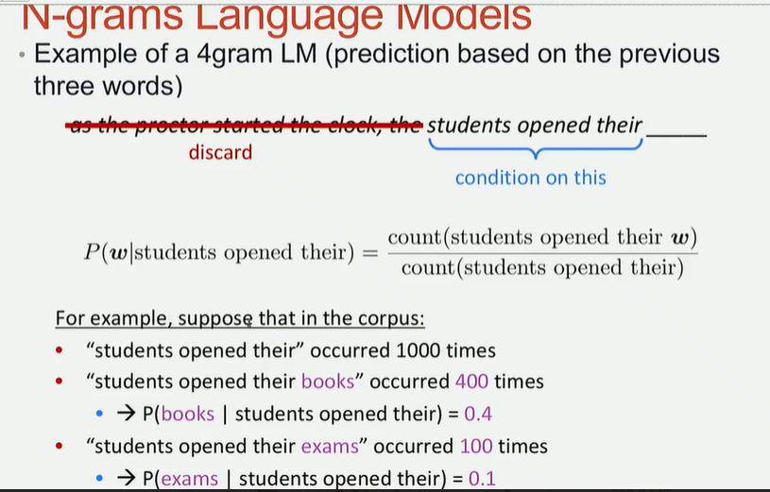
4 gram language model, basically discard what come before the maxim context

discard previous content and relay on the three before (it is a 4 gram)

count how many time the two words appear together divided by the number of counts of all the contect

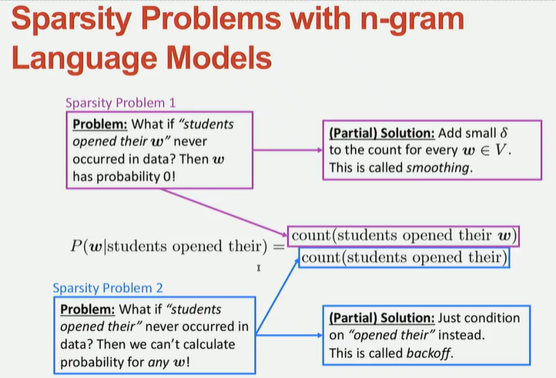
What if it is never occupied in the data? it has probability 0. We can rely to the smooth (non zero probability for all the other vocabulary).

But what if the contect never appeared in the data? if you have a 4gram then rely on the 3gram, reduce the ngram. Go to a smaller language model until we reach a unigram

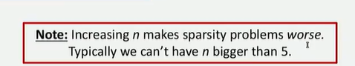
After 5 is not useful, the vocabulary is think and you need to storage all the probability

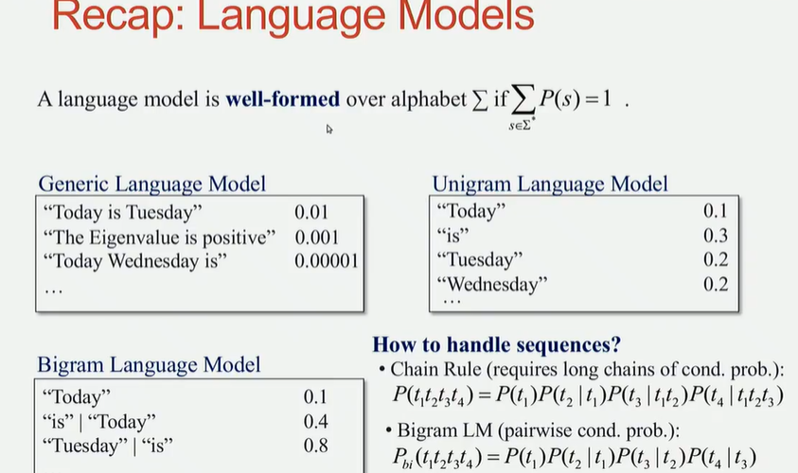
a language model is well formed if the sum of the conditional probability sum up to 1.

when we fix a context and we want to predict the probability given all target words that sum needs to be 1.

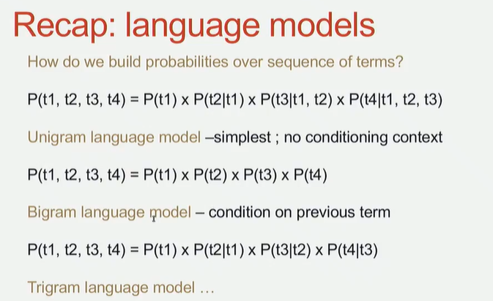

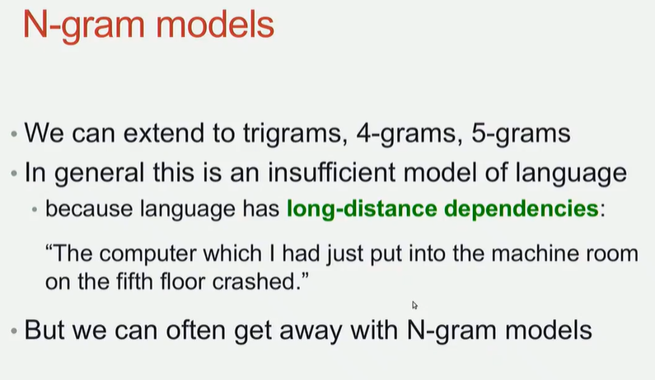
In general we can extend the ngram up to 5, but the limitation is that with the approximation we lose the long-distance dependencies

we care about the computer [...] crashed we lose the connection between the computer and crashed. there are some limitations that we can not overcome

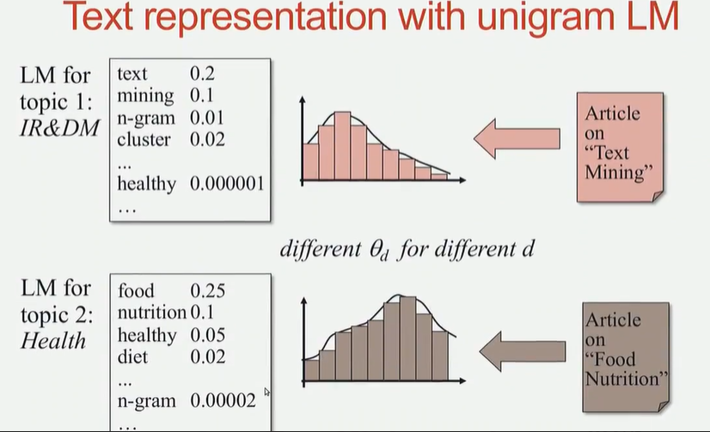
if you think about two different topics the distribution of the word will be different

you can learn two different models, not the same language model

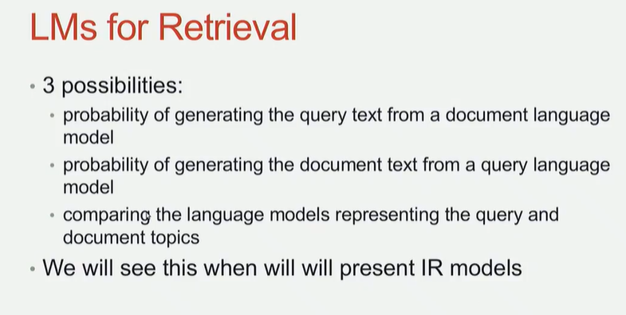
once we have a language model we can invent how to use the notion of probability in our application that we want to build

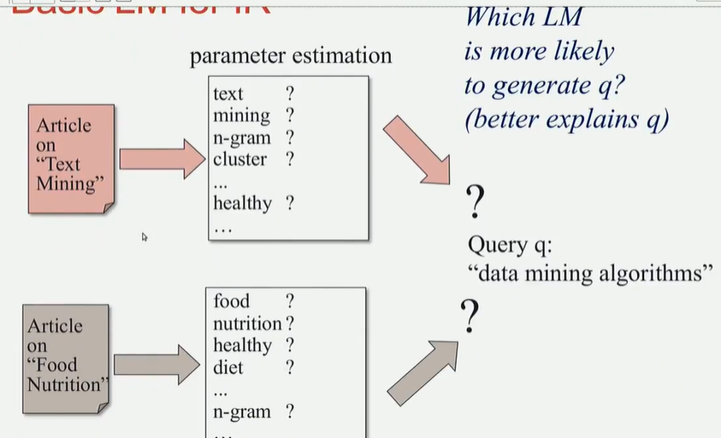
when you are in a context, then that language will have some bias on words that appear more often in that specific topic

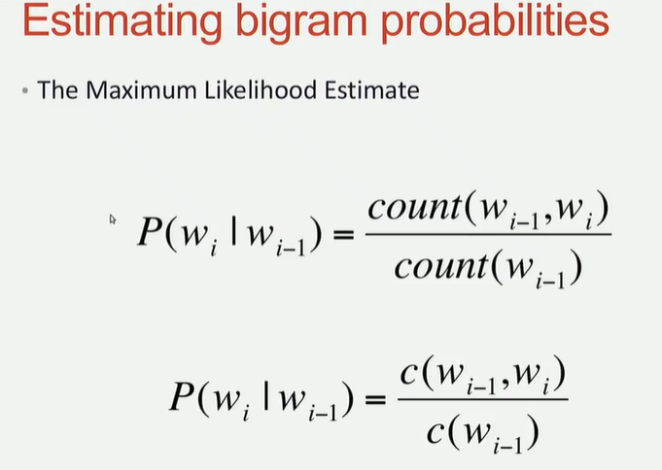
what we are counting is the maximum likelihood estimate that gives us the probability of a word given a context is computed just by counting

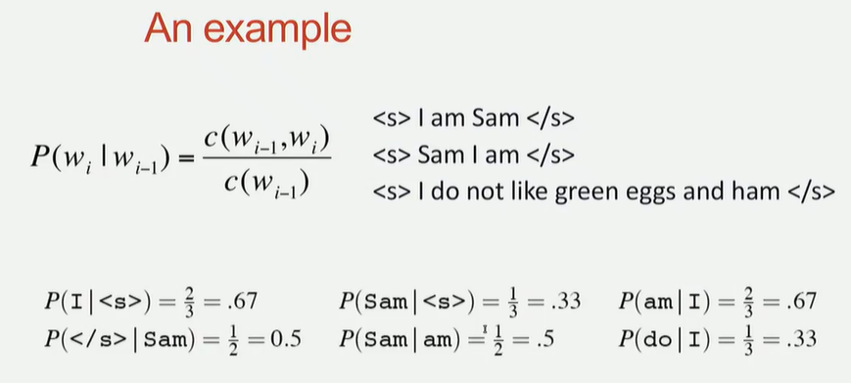
special token that indicates the start and end of a sentence
<s> start
</s> end

At some point I want to have some answer but at some times it has to stop the answer (like chatgpt). It can always come up with new words. We use special token that can be insert in the training data that helps a model to know when a sentence start and where to stop

then if the most likely token to be generated is </s> it will stop, because it reached a full sentence

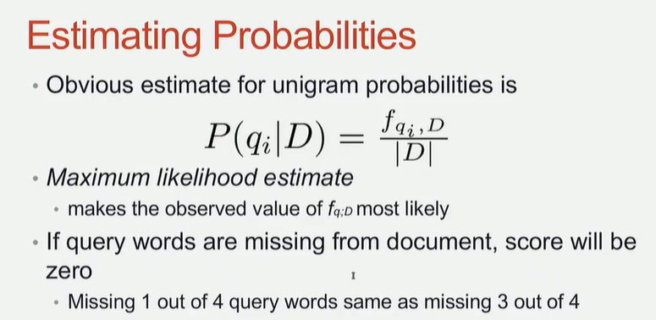
Instead of having one big document if we have different model and we want to compute a unigram probability is just how many times a word appear in a document given a list of documents.

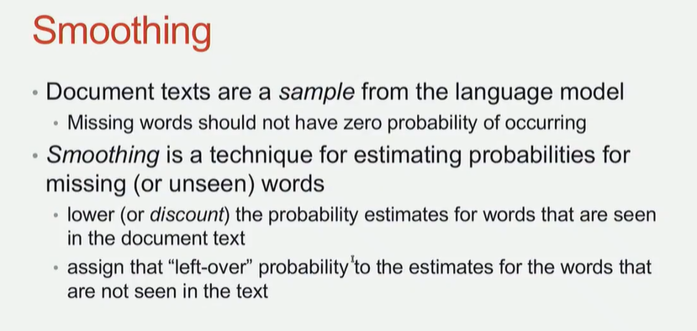
smoothing: a lot of words have 0 probability (not good) we want to avoid it. We need to assign some sort of probability. We want to compute some probability of a sentence if you have no smoothing technique than the model never see one combination that is in the sentence

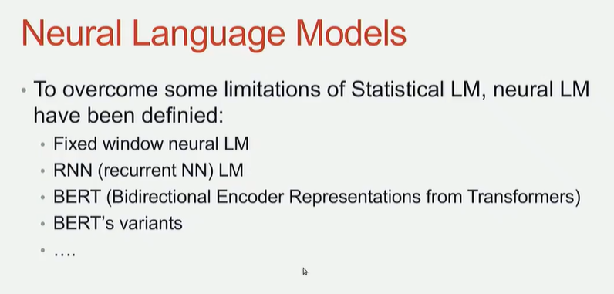
some limitation have been address with more powerful Language model process

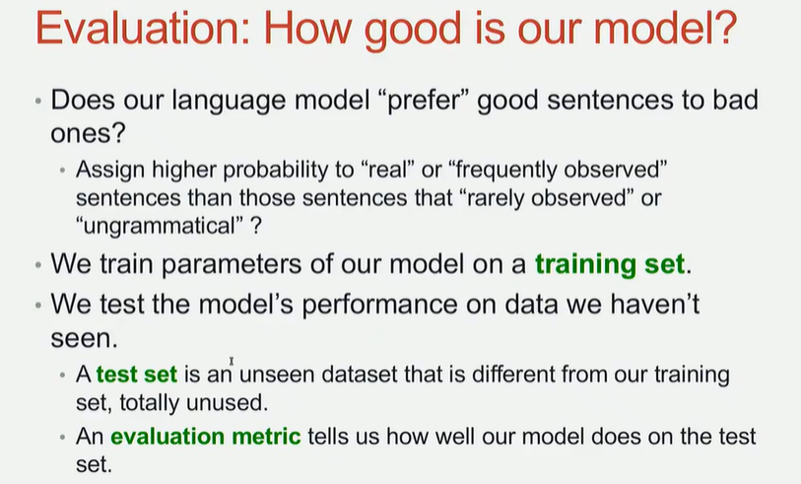
how to evaluate the model, how to decide if our language model is good or not, there is a measure.

you distinction between training data and test data
count all the probability on training date and use test data as a benchmark to compute the probability of a sentence. Is something never seen by the model, new combinations of words in the sentence. Check how good is the model

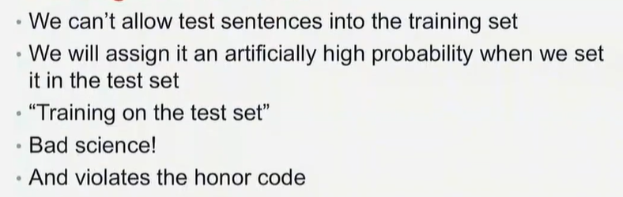
Whatever task we do you can not actually the test data to compute the matrix andn probabilities.

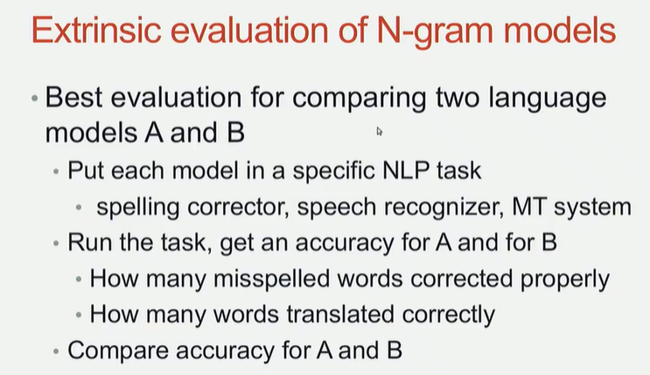
specific task for spelling correct, if you have a text with different candidates and no misspelling you just simply add misspelling of other words, and then you count probability for all the words

check if the model is doing the right thing or not, you get an accuracy score

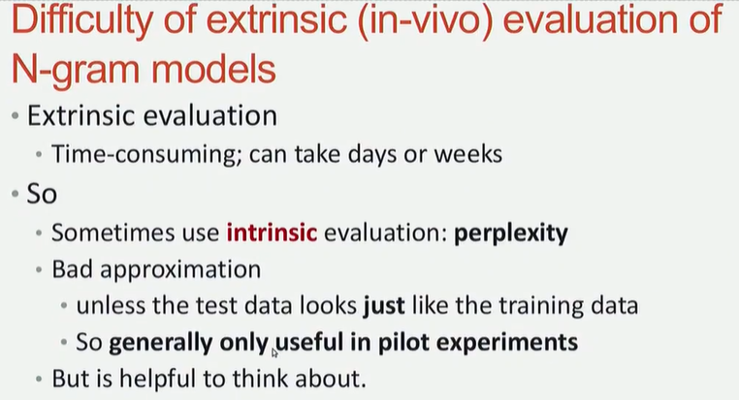
perplexity: train your model, instead of using it as an introduction for some task you actually use it as counting the perplexity measure.

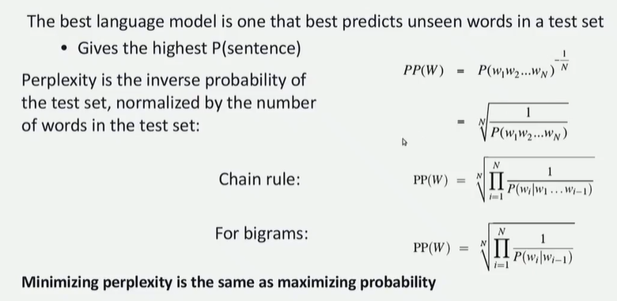
you count for each sentence the probability of each sentence and then you do the inverse.

the model with the lower plexpass is the better model, build a model that minimizes the perplexcity

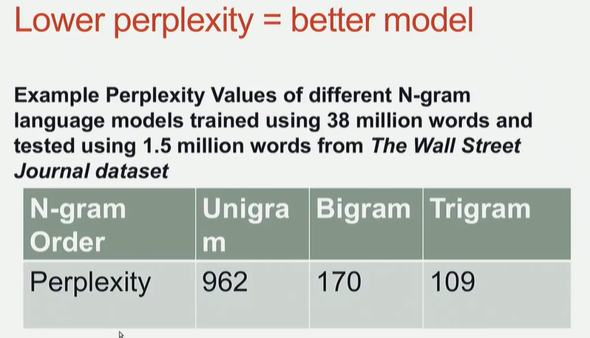
the trigram language model works better then unigram and bigram because it has lower perplexity

it produces better probability then the other one

